Table of Contents

Overview of the Project: 2

Customer Signup portal: 2

Purchase portal: 3

Customer login portal: 3

Tracking a claim: 3

Employee login portal: 3

Operations login: 3

Sales-product login: 3

Pre-Adjudication login: 3

Technical framework: 4

Environment: 4

Data Pre-processing: 4

Model building: 4

Premium prediction: 5

Product recommendation: 5

Fraud classification: 5

Image Classification: 5

Model Evaluation and pickling the models: 5

Premium prediction: 5

Product recommendation: 5

Fraud classification: 5

Front-end creation: 5

Results and Project Demo: 6

Landing Page: 6

New customer signup portal: 6

Purchase portal: 7

Customer ID and Password generation: 7

Customer login portal: 7

Claim submitted: 8

Employee login portal: 9

Pre-adjudication login portal: 9

Tracking a claim: 9

Further enhancements: 10

Future scope: 10

Conclusion: 10

# Overview of the Project:

The project's goal is to develop a management system for an insurance firm that uses machine learning and deep learning technologies to reduce the need for human intervention where it is necessary to exert a lot of manual labour. By offering them services like customer signup, claim submission, claim tracking, pre-adjudication procedure, and visualisation of all the data that is available to the company, our project will benefit both the company's clients and itself.

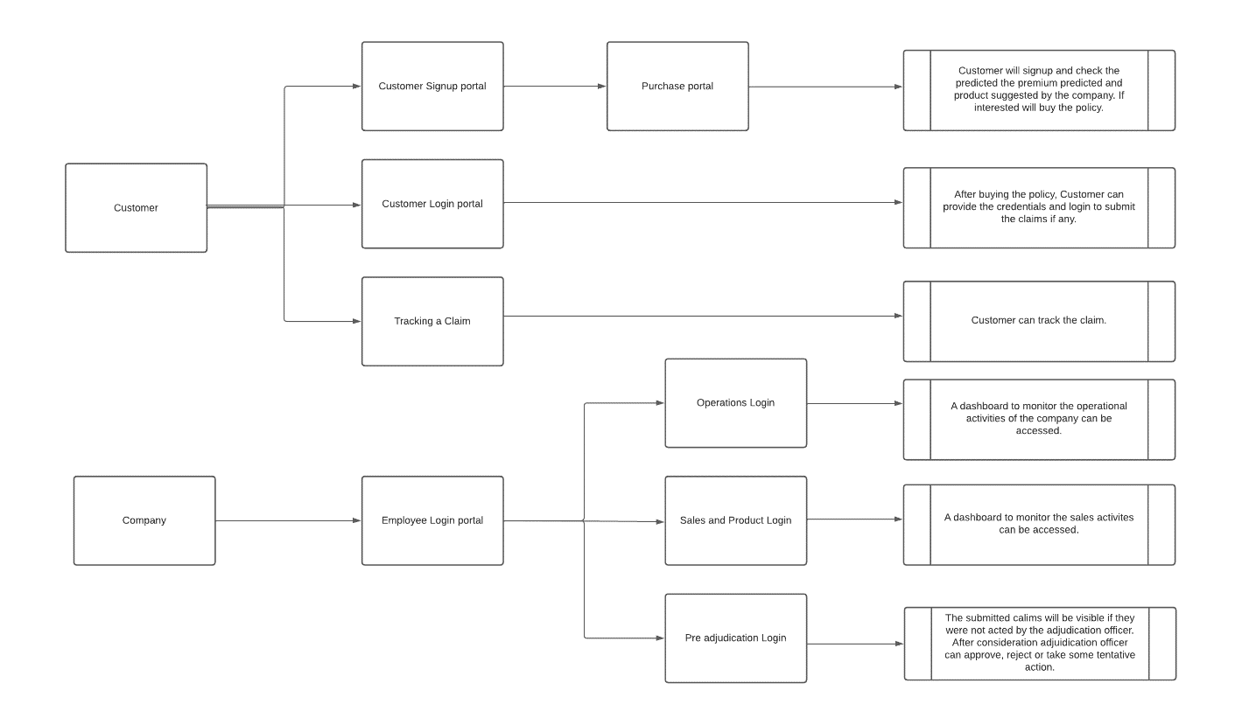

Figure : Overview of the project

## Customer Signup portal:

As soon as the visitor enters their response, they can choose this portal from the landing page. They will be led to the signup portal, where they must provide their demographic information (name, email, contact information, state, type of policy, vehicle information, age, and income, for example) and submit the signup form before being transferred to the purchasing portal. As the user provides their information, the user's information is recorded and saved in an excel file as the company receives queries.

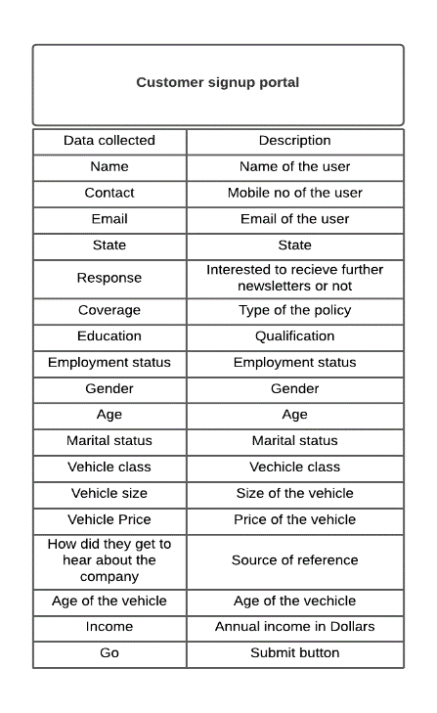

Figure : Customer signup portal

### Purchase portal:

## Following the user's completion of the registration form. The information gathered will be utilised to forecast the monthly car premium for all of the company's products. Additionally, the business will provide product recommendations based on data from past customers that shows the proportion of customers who are similar to the user that choose the advised product. A user ID and password are given to the customer after they click "Buy," allowing them to log in to the customer portal.

## Customer login portal:

The consumer can log in and verify the information on the portal by giving the credentials issued after the successful purchase of the product. There will be a feature that allows claims to be submitted using this site. The claim submission form is accessible and asks for information such as the incident date, the police report, the availability of witnesses, the Report number, the driver rating, the vehicle information, the vehicle photo, and any documents in PDF format.

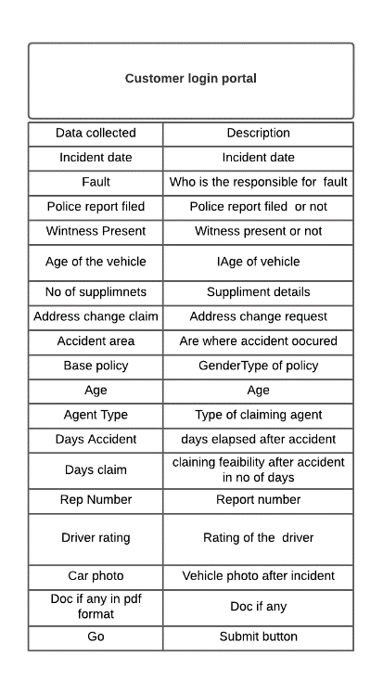

Figure : Customer login portal

## Tracking a claim:

The customer will receive a claim id after submitting the claim form, which they can use to check the status of the claim through the claim tracking site, which only requires the claim id and returns the claim's status upon submission.

# Employee login portal:

## Operations login:

## You can log in using the dummy login ID and credentials "EMP0002" (username and password are the same) to view dashboards for the false claims that can be viewed via this portal. On Tableau, the dashboards are created.

## Sales-product login:

You can log in using the dummy login credentials "EMP0001" (username and password are the same) to view dashboards for claims, sales operations, and other product-related dashboards that are accessible through this site. On Tableau, the dashboards are created.

The insights from both portals can be used for product development as well.

## Pre-Adjudication login:

Adjudication officer can use “ADJ” as a username and password to log in.

# This adjudicators-only portal enables the relevant authorities to evaluate the data following analysis. The claim's data will be examined for fraud; if fraud is discovered, the ML model will return "1," otherwise "0." Additionally, the supplied vehicle shot will go through a number of deep learning models for image categorization, which will indicate any damage to the vehicle.

# After reviewing the claim, they have the option to accept, reject, or conduct further research. Additionally, they have the option of marking revised statuses in the claim tracking portal.

# Technical framework:

## Environment:

The entire project was built on a python 3.10 environment using PyChram. The following are the requirements and directories used in the technical framework:

1. Templates
2. Data
3. Python files
4. static

**Templates:** All the HTML-front end pages are initialized in the templates directory of the environment.

**Data:** All the data that is required to train the models are stored in the data and even the output files after capturing the data are stored in this directory.

**Python files:** All the python files are directly available in the environment’s main directory.

**Static:** The output from certain deep learning models has been stored in the Static directory of the environment.

## Data Pre-processing:

The data that has been catered is pre-processed and below are the steps followed in the pre-processing:

1. The variable selection happened by checking the correlation between the variables if they have any impact on the dependent variables.
2. Missing values were checked. There weren’t any missing values in the data set.
3. Outlier treatment has been done after identifying the existence of outliers in certain variables.
4. Separation of variables based on their type i.e., categorical or numerical has been done.
5. The categorial variables are encoded using the label encoding technique.
6. The encoded data has been scaled using the standard scaler.

## Model building:

The pre-processed data then has been split into independent and dependent variables namely X and Y.

The data has been split into training data and testing data using sklearn library in an 80:20 ratio. The training and testing dataset for image classification was directly obtained from Kaggle.

### Premium prediction:

### For all of the company's products that are now accessible, the premium based on the user's input will be calculated using a variety of regression approaches, including Linear regression, Decision trees, Support vector regressors, and Random forests.

### The training data obtained after pre-processing was used to fit the models. The test data was used to forecast the premium, while the remaining data was utilised to assess the models.

### Product recommendation:

### A variety of classification models, including Logistic Regression, Support Vector Machines, Gaussian Naive Bayes, Decision Tree Classifiers, KNN Classification, and Gradient Boosting Classification, have been applied to the product that needs to be recommended to the consumer.

### The training data obtained after pre-processing was used to fit the models. With the use of the remaining data and the test data, the product was predicted while evaluating the models.

### Fraud classification:

### A variety of classification models, including Logistic regression, Support vector machines, Gaussian Naive Bayes, Decision tree classifiers, KNN Classification, and Gradient Boosting Classification, have been applied to the data that the claimant gave.

### Image Classification:

Using ImageDataGenerator, the training dataset was read in the data form and the photos were resized. To ensure that the training dataset had been adequately fitted to the model for 58 number of EPOCHs, the data was processed through some convolution layers and pooling layers. The best model will be preserved utilising early stopping once the best accuracy has been achieved.

## Model Evaluation and pickling the models:

### Premium prediction:

### The best model will be saved in a pickle file once the fit models have been evaluated using MAPE-Mean absolute percentage error. In order to estimate the premium with the optimal model, the pickle file will be called when a user enters data into the site.

### The models have occasionally predicted the premium with a 95% accuracy rate.

### Product recommendation:

### The fittest model will be saved in a pickle file after being tested using classification accuracy. In order to categorise and recommend the product with the best model, the pickle file will be called when a user enters data into the portal.

### Although ensemble modelling was done, the data did not support the classification models' ability to forecast with more precision, as evidenced by the accuracy of the models being around 50%. The performance component was therefore left for future improvement.

### Fraud classification:

The fittest model will be saved in a pickle file after being tested using classification accuracy. In order to identify the fraud claims with the best model, the processed information will be run using the pickle file when a user enters data into the claim submission portal.

## Front-end creation:

All of the necessary pages for the front end that can generate output and gather user data were constructed using HTML. Simple HTML was used and left to be improved.

In the app.py file, where the entire process has been defined from scratch, the front end and the python files were integrated using flask.

# Results and Project Demo:

## Landing Page:

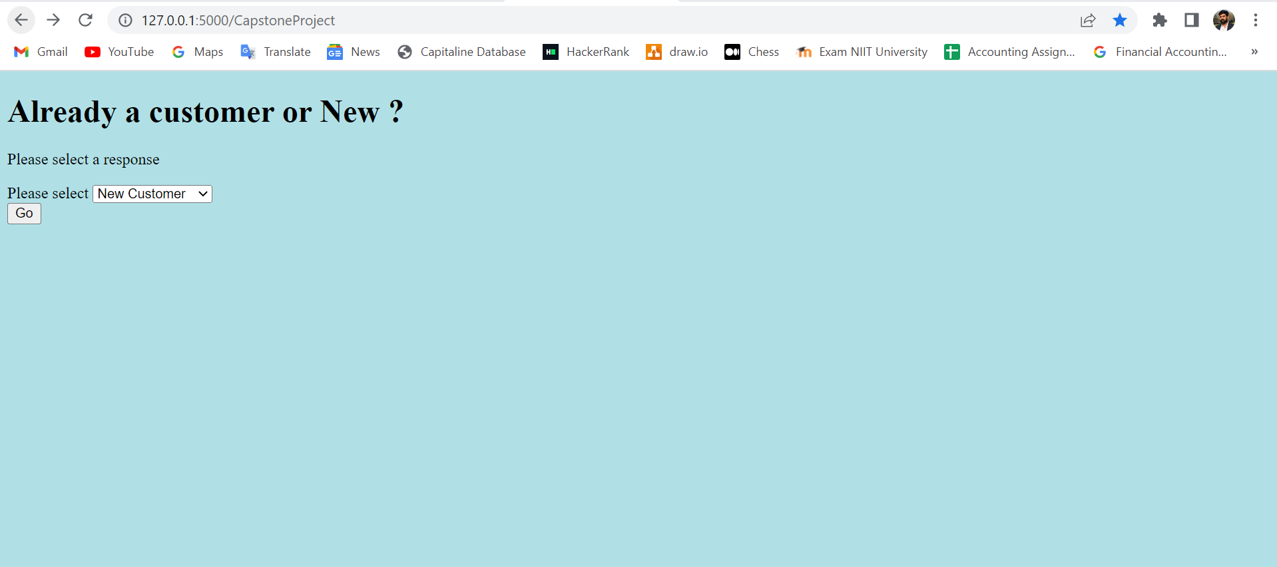

The landing page shown above requests that you choose a response from a drop-down menu that includes options like New Customer, Already Insured, Employee Login, and Track a Claim. They are intended for new customer registration, customer login for claim filing, employee login for other company-related tasks, and claim tracking, in that order.

## New customer signup portal:

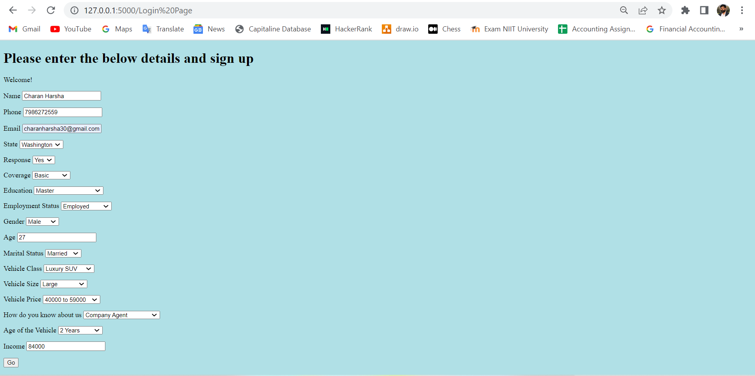The user must complete the aforementioned web pages before being redirected to the purchasing portal, where the premium and product are predicted based on the information provided by the user.

## Purchase portal:

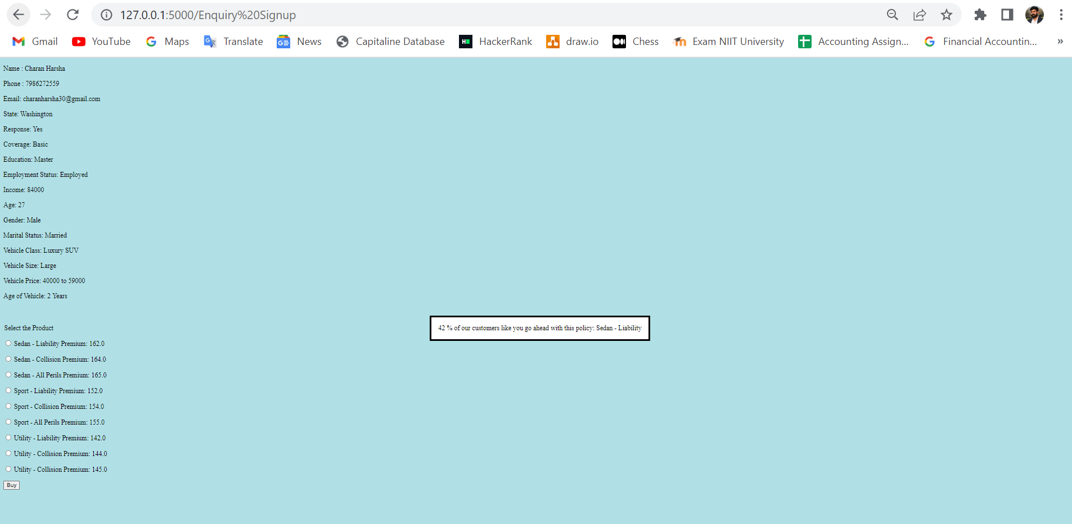

## The user will be taken to the purchase gateway after providing the details. The portal requests that you choose the product with the expected premium while also recommending the one that shows the user type's customer conversion rate.

## Customer ID and Password generation:

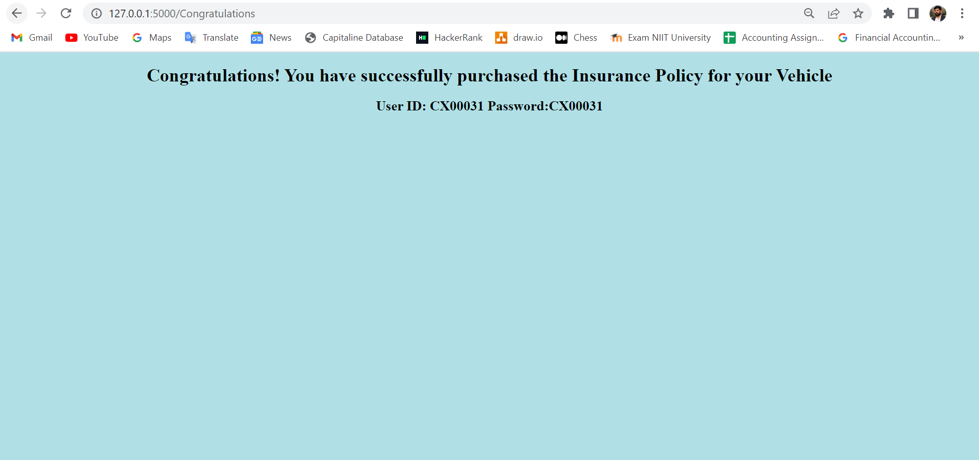

## The user is now a client. The consumer is now given a user ID and password that can be used to access the login page for insured customers.

## Customer login portal:

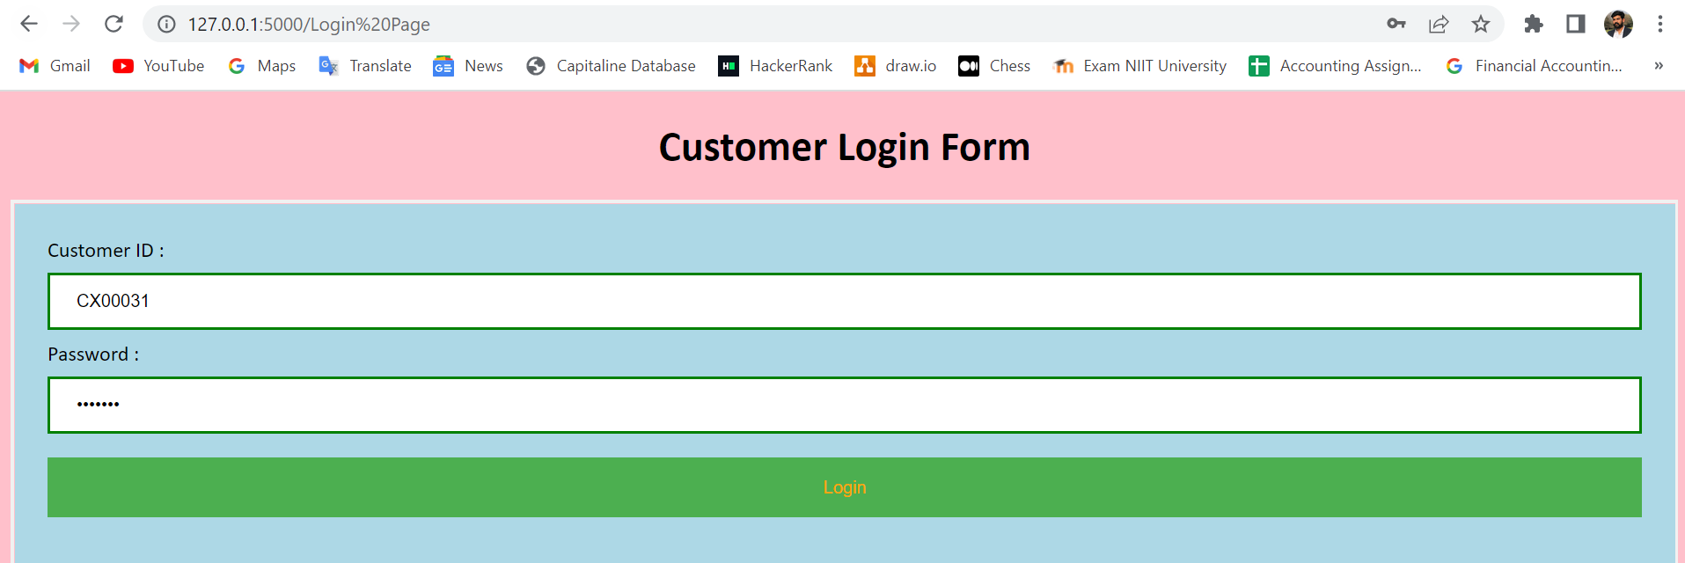

Using the login information given to them after purchasing the policy, the consumer can log in.

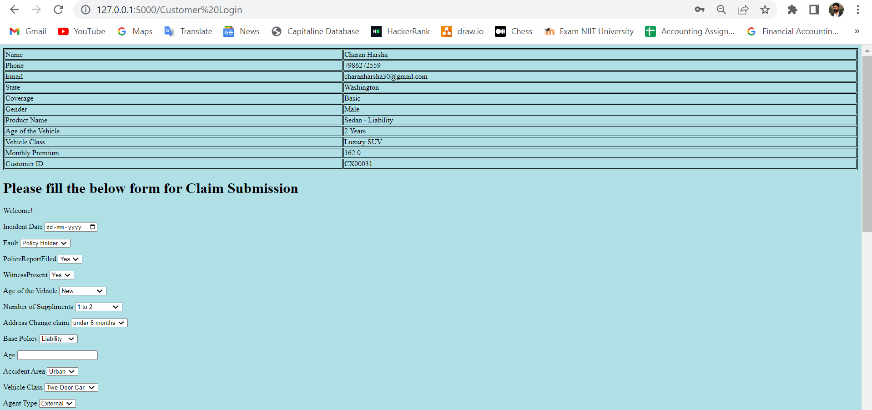



## To submit a claim, fill out the form above and upload the car photo from the incident along with any other policy-related documents in pdf format.

## Claim submitted:

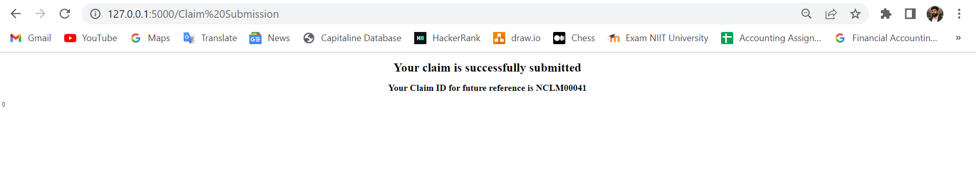

When a claim is successfully submitted, a claim id is generated and shown to the customer for future reference.

## Employee login portal:

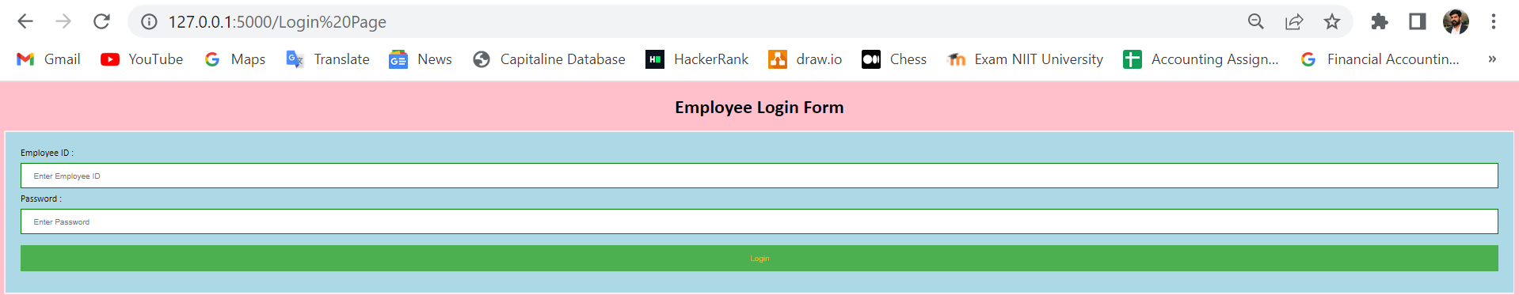

### Pre-adjudication login portal:

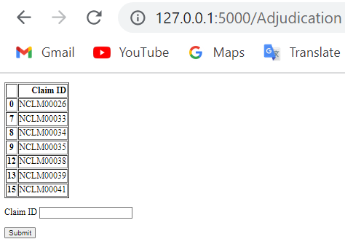

On order to log in, the adjudication officer must enter their credentials. On their portal, they will be able to view the tasks and claims that have been open and unacted upon since their inception. To continue with the pre-adjudication procedure, they can enter the claim id.

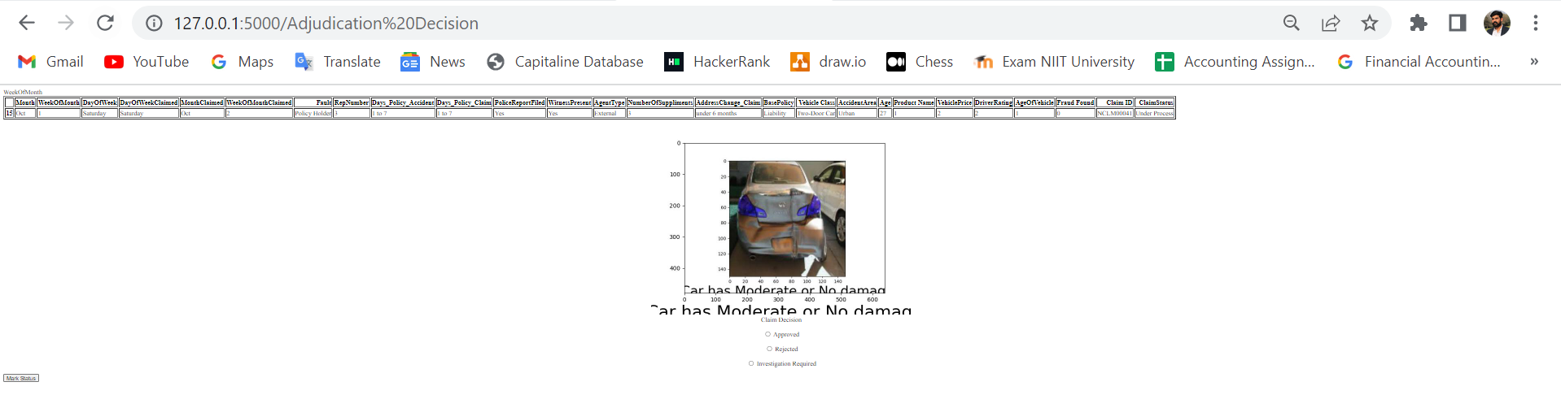

## The portal will include the results of the analysis of information such as predictions of fraudulent claims and image categorization. The adjudication officer will make the choice. The adjudication officer will refer them to the open cases portal for new duties after they have had their status marked by the officer.

## Tracking a claim:

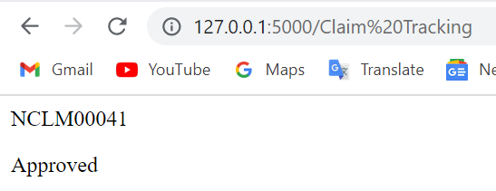

# The customer can utilise the claim tracking portal to look up the status of a previously submitted claim.

# Further enhancements:

# • Using a variety of methods, the customer signup from the data being acquired can be minimised.

# • By experimenting with several additional models or deep learning techniques, the accuracy of the product recommendation portion can be increased.

# • More accurate image segmentation and classification are possible for damage identification. To reduce risk, fraud classification needs more balanced data and algorithms.

# • The front end can be expanded upon or improved.

# • All of the project's data can be transferred to the cloud and stored there in a cloud database. The visualisations in real time will be possible.

# • For more effective demonstrations, the project can be deployed and made available to everyone.

# • By changing the algorithms, the complete project may be created as a plug-and-play application for an insurance firm.

# Future scope:

# The project has a fantastic potential scope because so many businesses still rely on human labour to carry out their operations in various management roles, as we have observed. This kind of project will undoubtedly assist in the recommendation of an insurance product, the acquisition of an insurance policy, fraud detection, damage detection, claim adjudication, product creation, and dashboard-optimized business decision-making, among other things. On the other hand, if customer claims are resolved as swiftly as possible, customer retention and new client acquisition will be simple, and the customer will undoubtedly experience the highest degree of pleasure. The creation of new products necessitates a great deal of brainstorming, which calls for the analysis of data gathered from clients and produced by internal calculations. The use of reporting and business intelligence technologies like Tableau, Power BI, etc. will enable this.

# Conclusion: